Random walk 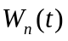

For n a positive integer, define the binomial process to have:
- 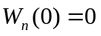
- layer spacing 1/n
- up and down jumps equal and of size 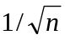
- measure P, given by up and down probabilities everywhere equal to ½

If 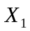,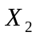,… is a sequence of independent binomial random variables take values of 1 or -1 with equal probability, then the value of 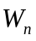at the ith step is:

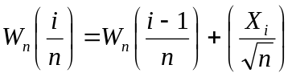 for all i >= 1

Brownian Motion

The process 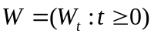is P-Brownian motion if and only if
- 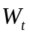 is continuous and 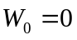
- the value of is distributed, under P, as a normal random variable N(0, t)
- the increment 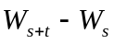is distributed as a normal N(0, t), under P, and is independent of 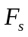, the history of what the process did up to time s.

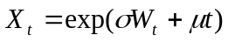is exponential Brownian motion with volatility σ and drift μ.

Stochastic processes

F-previsible means that at a given node i the value at i is only dependent on the history at i – 1.

A stochastic process X is a continuous process 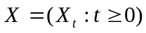such that 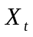can be written as
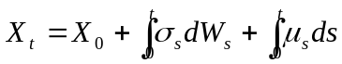

where σ and μ are random F-previsible processes such that 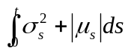is finite for all times t with probability 1. The differential form of this equation can be written:

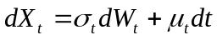

Ito’s formula

If X is a stochastic process satisfying and f is a deterministic twice continuously differentiable function then 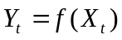 is also a stochastic process and is given by:

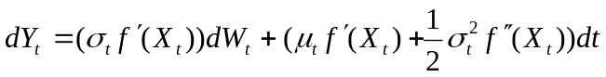

Equivalence

Two measures P and Q are equivalent if they operate on the same sample space and agree on what is possible. Formally, if A is any event in the sample space,

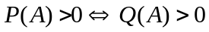
Radon-Nikodym

This is all about change of measures and how to do it.
Given P and Q equivalent measures and a time horizon T, we can define a random variable 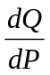 defined on P-possible paths, taking positive real values, such that
- 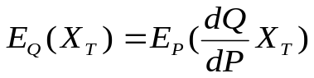, for all claims 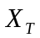knowable by time T.
- 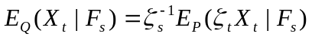, s <= t <= T, where 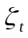is the process 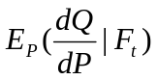.

Identifying Normals

A random variable X is normal 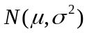 under a measure P if and only if:

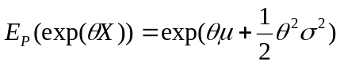, for all real θ.

Cameron-Martin-Girsanov Theorem

If is a P-Browning motion and 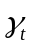is an F-previsible process satisfying the boundedness condition 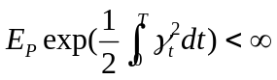, then there exists a measure Q such that:
- Q is equivalent to P;
- 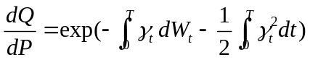;
- 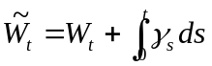is a Q-Brownian motion.
In other words, is a drifting Q-Brownian motion with drift 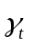at time t.

Cameron-Martin-Girsanov converse

If is a P-Browning motion and Q is measure equivalent to P, then there exists an F-previsible process such that is a Q-Brownian motion. That is to say, plus drift is Q-Brownian motion. Additionally, the Radon-Nikodym derivative of Q with respect to P at time T is 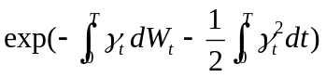.

Martingales

A stochastic process 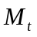is martingale with respect to measure P if and only if:
1.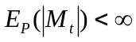, for all t.
2.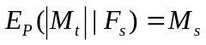, for all s ≤ t.

Martingale representation theorem

is a Q-martingale process and its volatility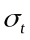satisfies the additional condition that it is always non zero. 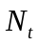is another Q-martingale process. Then there exists a unique F-previsible process ϕ such that 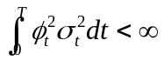and N can be written as:

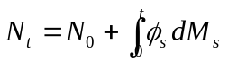.
Martingale fact

If X is a stochastic process with volatilityand satisfies the technical condition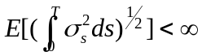 then: X is martingale ⇔ X is driftless.

Exponential martingale fact

If 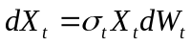 for some F-previsible process, then 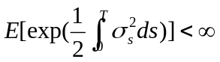⇒ X is martingale. Furthermore, the solution to the SDE is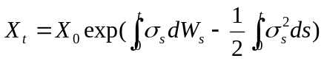.

The portfolio (φ, ψ)

A portfolio (φ, ψ) is a pair of processes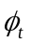and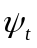which describe respectively the number of units of security and of the bond that we hold at time t. The processes can take positive or negative values as we allow unlimited short selling of the stock or bond. The security componentof the portfolio should be F-previsible: depending only on information up to time t but not t itself.

Self-financing property

A portfolio is self-financing if and only if the change in its value only depends on the change of the asset prices.

Formally, if 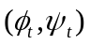is a portfolio whose value at time t is 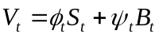with stock price 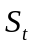and bond price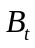, then:

is self-financing ⇔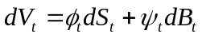.

Replicating strategy

We have a riskless bond B, a risky security S with volatility and a claim X on events up to time T. A replicating strategy for X is a self-financing portfolio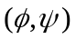such that 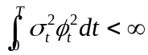and 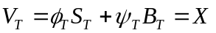.
Black-Scholes model (basic)

We have deterministic r, μ and σ so that the bond and stock prices are:

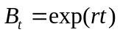
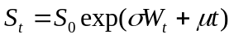

where r is the riskless interest rate. σ is the stock volatility and μ is the stock drift. There are no transaction costs and both instruments are freely and instantaneously tradable either long or short at the price quoted.

Three steps to replication

- Find a measure Q under whichis martingale.
- For the process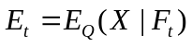.
- Find a previsible processsuch that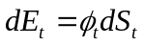.

Self-financing strategy

A portfolio strategyof holdings in a stockand a non-volatile cash bond has value and discounted value 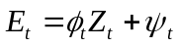, where Z is the discounted stock process 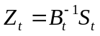. Then the strategy is self-financing if either

,
or equivalently 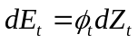.

Furthermore, as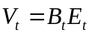, 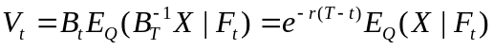.

Three steps to replication (discounted case)

- Find a measure Q under which the discounted stock priceis martingale.
- For the process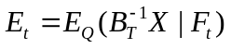.
- Find a previsible processsuch that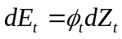.

Black-Scholes formula (for a call option).

Let 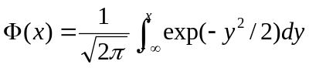, i.e. the probability that a normal N(0, 1) has value less than. Let 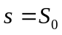 and k be the strike price of option. Then:

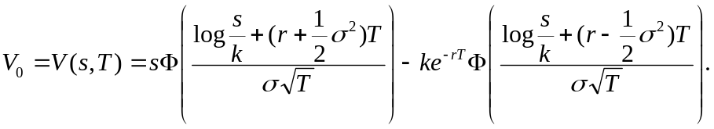

Pricing derivatives with optionality (e.g. American options)

The option purchaser has a set of options A and receives a pay off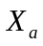at time T. After choosing an a in A, the option issuer should charge:



